**React Crash Course:** [**https://www.youtube.com/watch?v=w7ejDZ8SWv8&t=74s**](https://www.youtube.com/watch?v=w7ejDZ8SWv8&t=74s)

**What is react?**

React is a library for building user interfaces

React runs on the client as a single page app, but can be used to build full stack apps by communicating with a server/API

**Why you use it**

Structure the “view” layer of application

Reusable components with their own state

JSX – Dynamic markup

Interactive Ui’s with virtual DOM

Performance and testing

Very popular in the industry

**What to be familiar with:**

Promises and asynchronous programming

Array methods like forEach() and map()

Fetch api and making http requests.

**UI Components**

When using react, think of the UI as a bunch of separate components

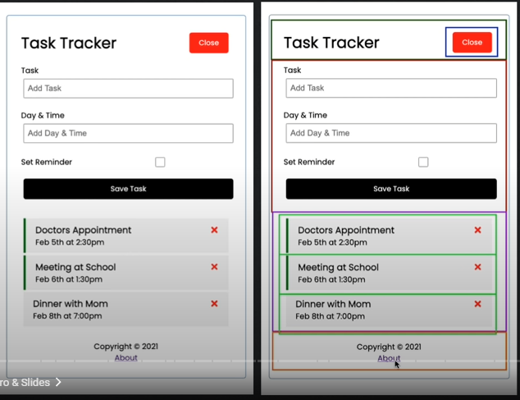

Components: Functions vs. Classes:

// component made with funciton

export const Header = () => {

    return (<div>

        <h1>My header</h1>

    </div>

    )

}

// component made with class

export default class Header extends React.Component {

    render() {

        return (<div>

            <h1>My Header</h1>

        </div>

        )

    }

}

Components render / return JSX (javascript syntax extension)

Once we make a component we can embed it into other stuff

Components can also take in props: (attributes e.g., title=”

<Header title=My Title”/?

Components aren’t static they can be dynamic, they have state. Which is an object that determines how a component renders and behaves.

“app” or “global” state refers to state that is available to the entire UI and not just a single component.

History lesson: prior to react 16.8, class-based components had to be used if we wanted to keep track of sate.   
  
Now we can use functional components with *hooks*.

Getting started:

**Create react app**

<https://reactjs.org/docs/create-a-new-react-app.html>

**Build for Production**

Use npm run build – to generate build files

Sudo* npm install -g serve

Serve -s build -p 8000

*sudo for mac and linux systems, for windows, run as administrator

**Using Server**

Install

Npm install json-server (install locally)

Create script to run server

"server": "json-server --watch db.json --port 5000"

Package.json

Npm run server